**Creating a Report Using the Wizard**

Creating a report using the Wizard is easy. These are the steps we need to follow to develop a text report in Visual Studio 2017:

1. Click on “File” and select “New Project” from the dropdown menu. Then, will pop up another window where we need to expand the “Business Intelligence” option. From the options displayed on that menu select the report wizard but before hitting “OK” make sure that you uncheck the “create directory for solution”. Give it a proper name and a proper location.

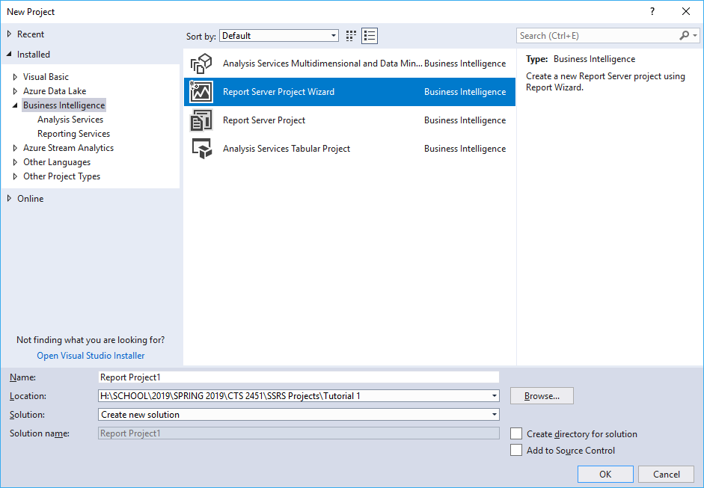

1. 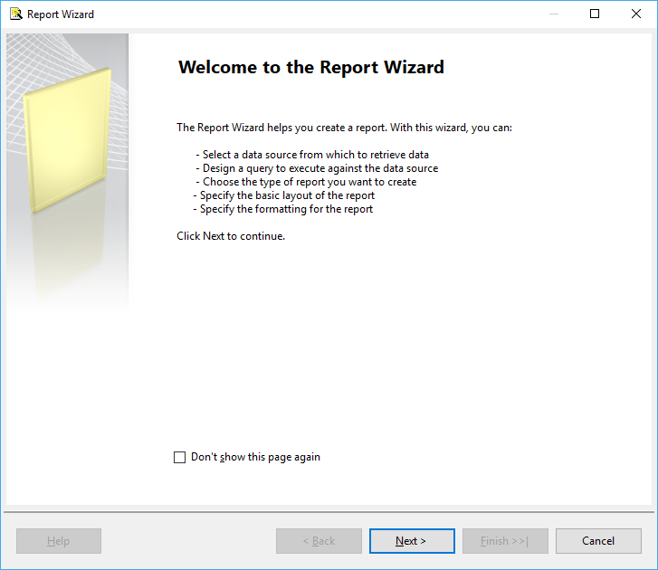The Report Wizard will open and then we hit Next.
2. Proceed to Select the data source that will feed our project. Select New data source and from the dropdown OLE DB (we are selecting this option because it is better to use the Visual Query Designer instead of the text query designer).
3. 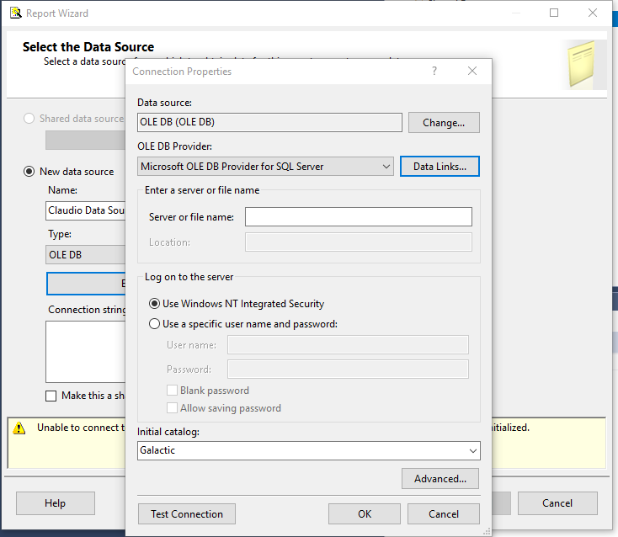When pressing the “Edit” button will be taken to the Connection Properties windows. There we select the provider: Microsoft OLE DB Provider for SQL Server and on the Log on to the server options we select “Use Windows NT Integrated Security” which is the “Windows authentication” when connecting to a Database in SSMS. Then we expan the initial catalog drop down and select the Galactic Database. The final step in that window is to test the connection between VS 2017 and the Datasource.
4. On the Report wizard window check the “Make this a shared data source” checkbox. By doing so we are sharing that data source for future reports.
5. Then we proceed to use the query builder. We click on the add table button and select the check the “Customer” table. After that we need to check “Name”, “Billing Contact”, and “Billing Email” fields from the table. On the fields pane we set up the Sort Type to be ascending by name.
6. On the text query we can see the that SSRS is autocompleting out query or autogenerating the code for us. If we need to check if we are pulling the right data then we can press the Run button located at the top of the query designer and with an exclamation sign.
7. 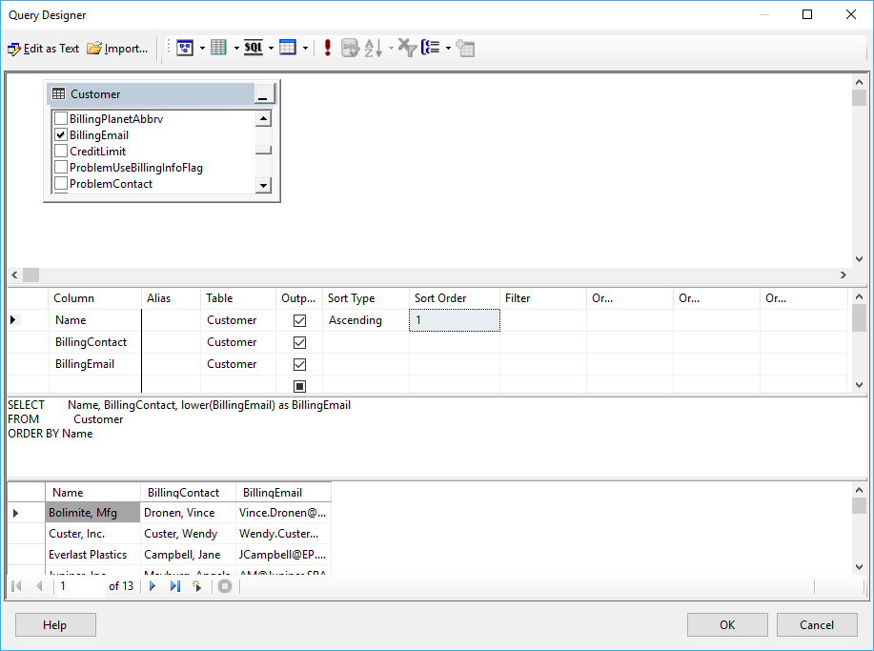Notice that the Billing Email has characters in upper an lower letters. To fix that we can go and change the query.
8. Select the Tabular Report Type and drag all the fields to be on the Details side.
9. Give a name to your report and we are ready by then.

